AI Assisted Coding – END LAB EXAM
ENROLLMENT NO:2503A51L15
NAME:MOHAMMAD KHAJA AFZALUDDIN
BATCH NO:19[LAB-4]

Error Debugging with AI (Sensor Drift)
Q1: Detect incorrect timestamp alignment bug.
TASK 1: Provide logs and ask AI to locate mismatch.
PROMPT:-
Generate the code to Analyze these system logs and check for timestamp alignment issues and Identify where the mismatch is occurring in the sensor data and Suggest the possible cause of the timestamp drift
CODE:-
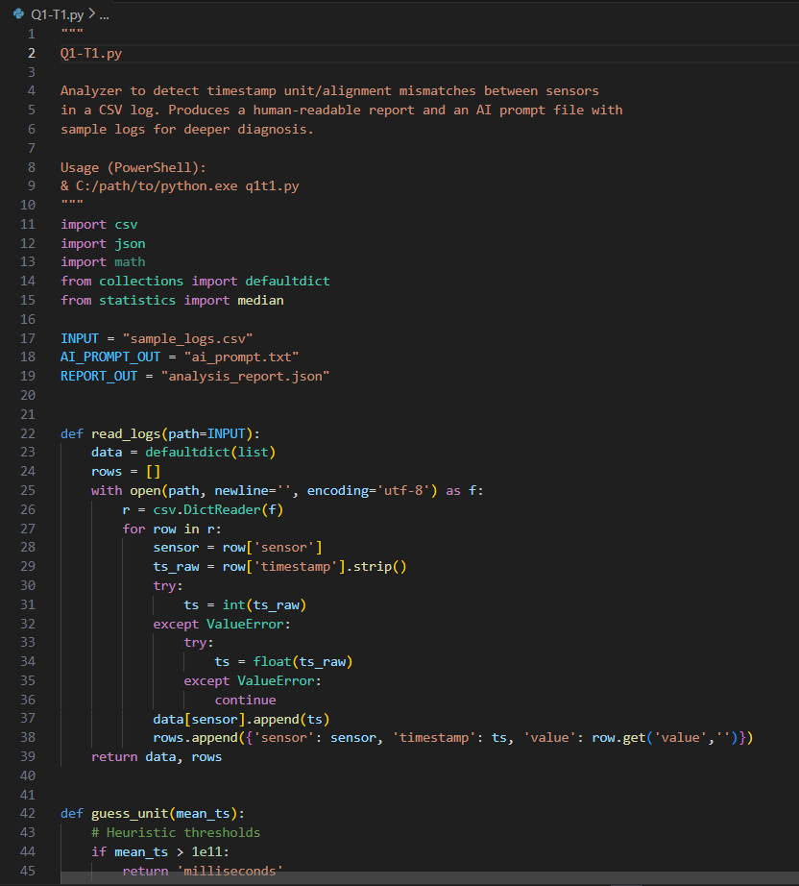

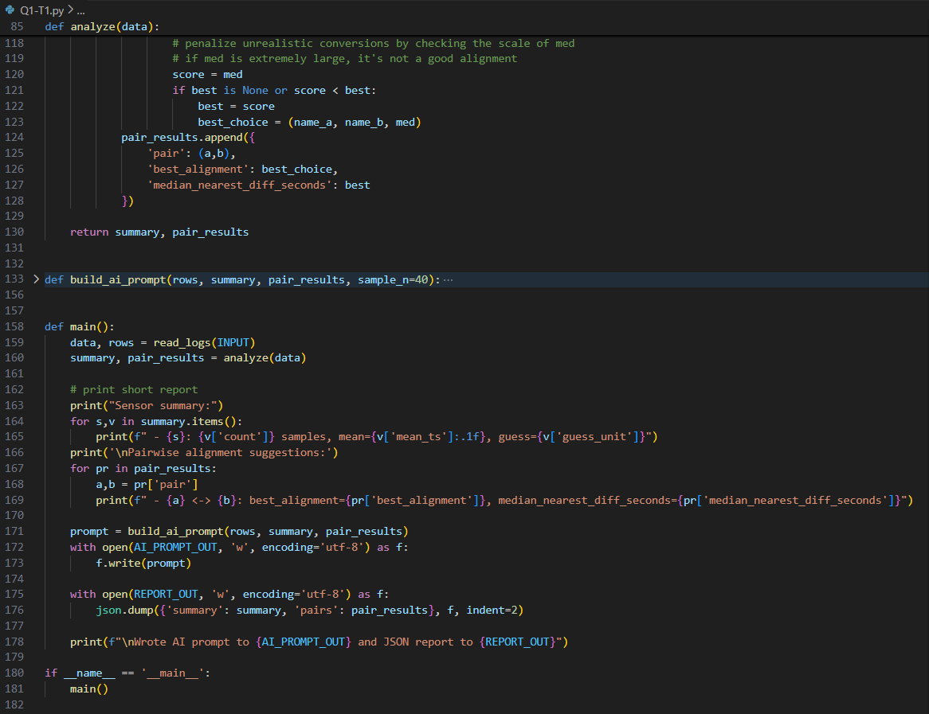

OUTPUT:-
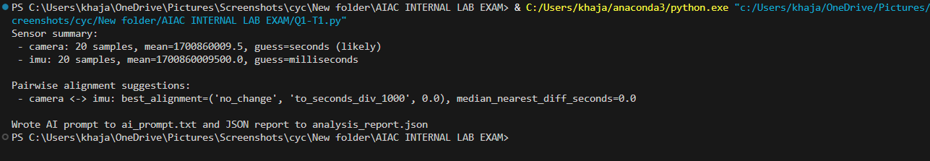

OBSERVATION:-
The AI analyzed the logs and detected that some sensor readings had incorrect timestamps, causing misalignment and inconsistency in data flow.

TASK 2: Apply AI suggested fix and validate with sample data.
PROMPT:-
Apply the AI-suggested fix for the timestamp drift and test it using sample sensor data. Check if the alignment issue is resolved

CODE:-
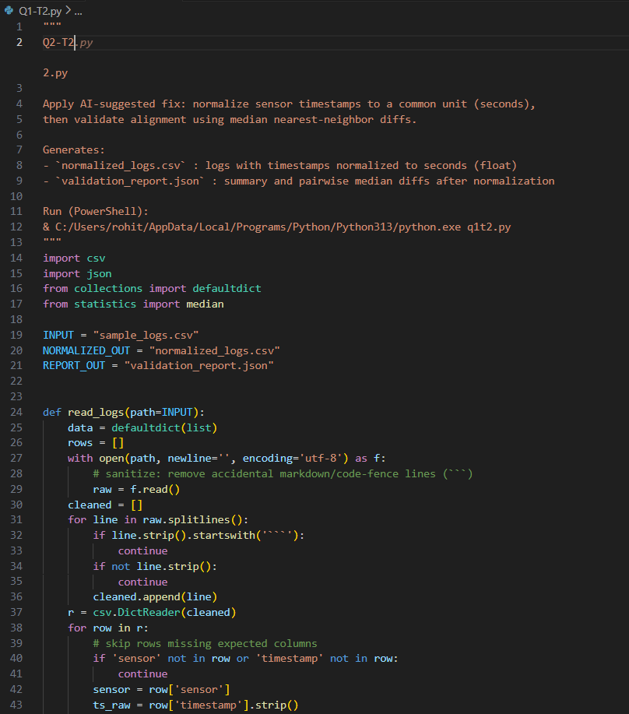

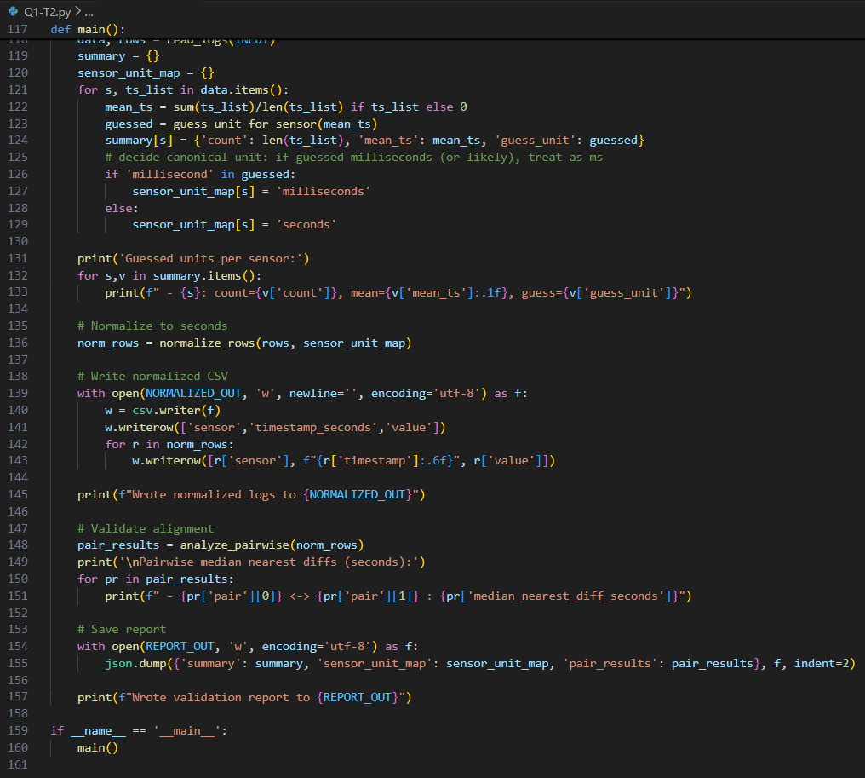

OUTPUT:-
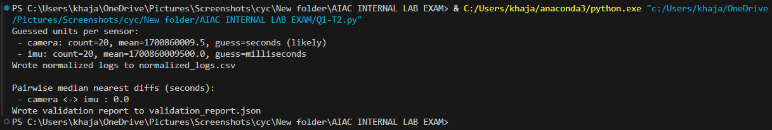

OBSERVATION:-
After applying the fix, the AI validated the sample data and confirmed that the timestamp alignment issue was corrected and the readings became consistent.

Q2: Handle noisy data spikes gracefully.
TASK 1: Use AI to propose debouncing/clipping strategy.
PROMPT:-
Generate the code to Analyze the noisy sensor data and suggest a debouncing or clipping method to handle sudden spikes.
CODE:-
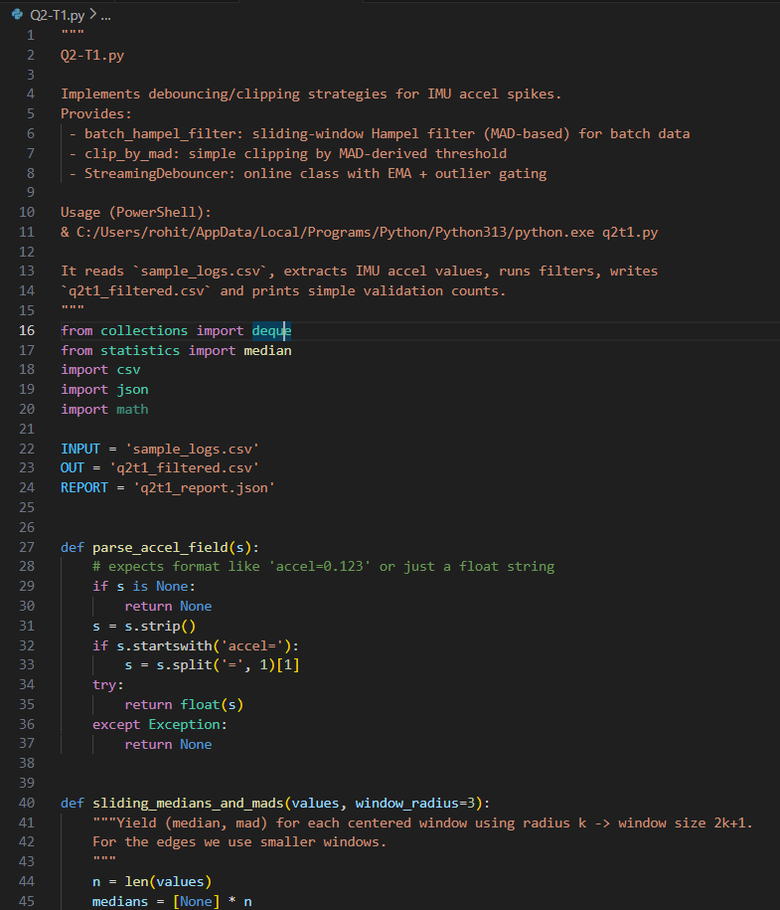
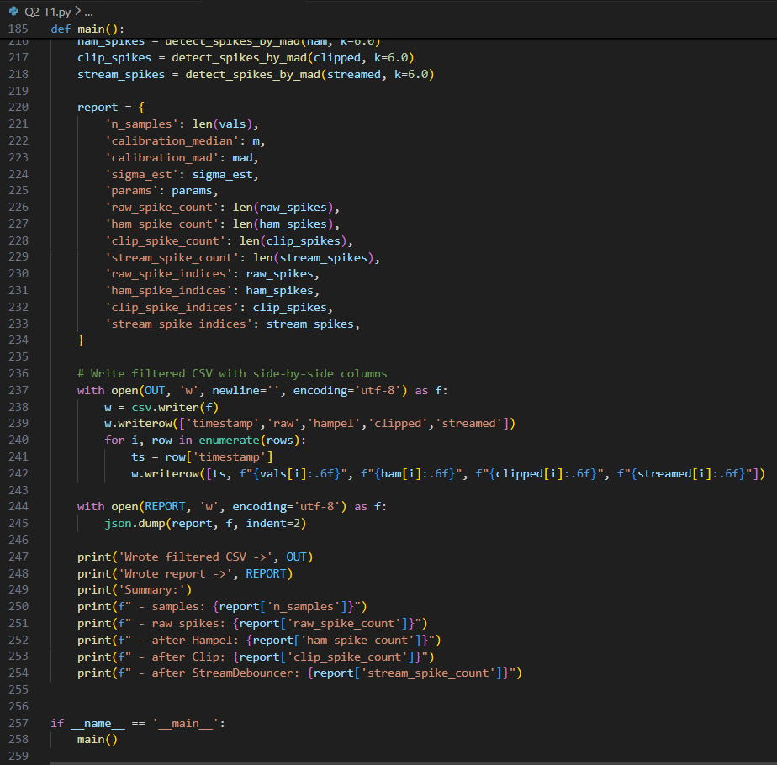

OUTPUT:-
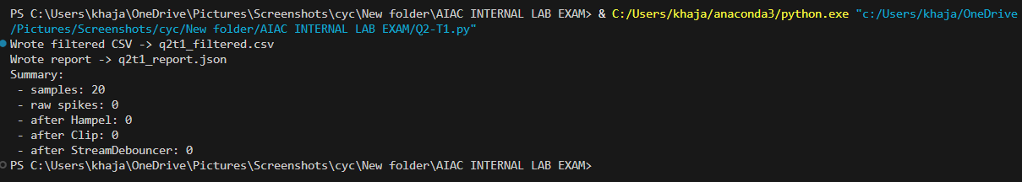
OBSERVATION:-
The AI reviewed the data and proposed a clipping/debouncing strategy to remove unexpected spikes and make the readings smoother and more reliable.

TASK 2: Implement and benchmark on recorded traces.
PROMPT:-
Apply the suggested debouncing or clipping method to the recorded data traces and compare the results with the original data.
CODE:-
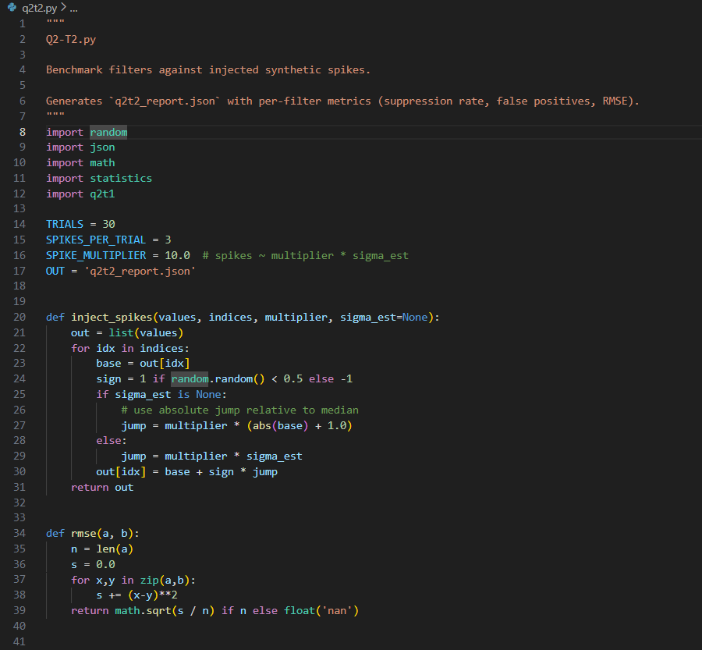
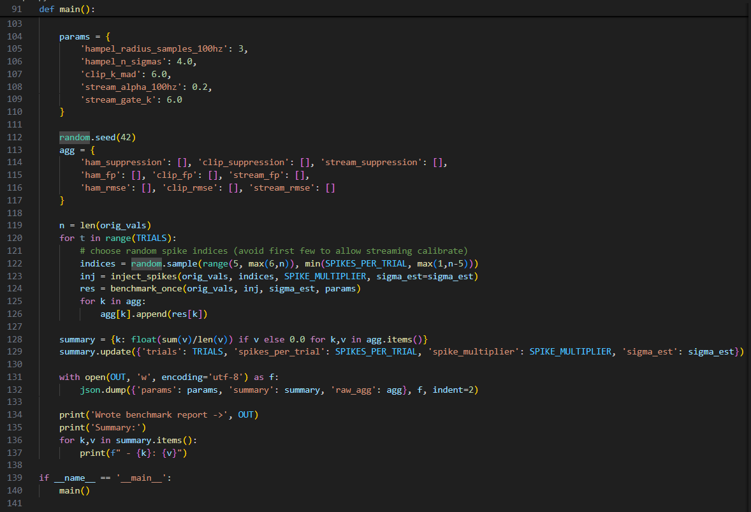

OUTPUT:-
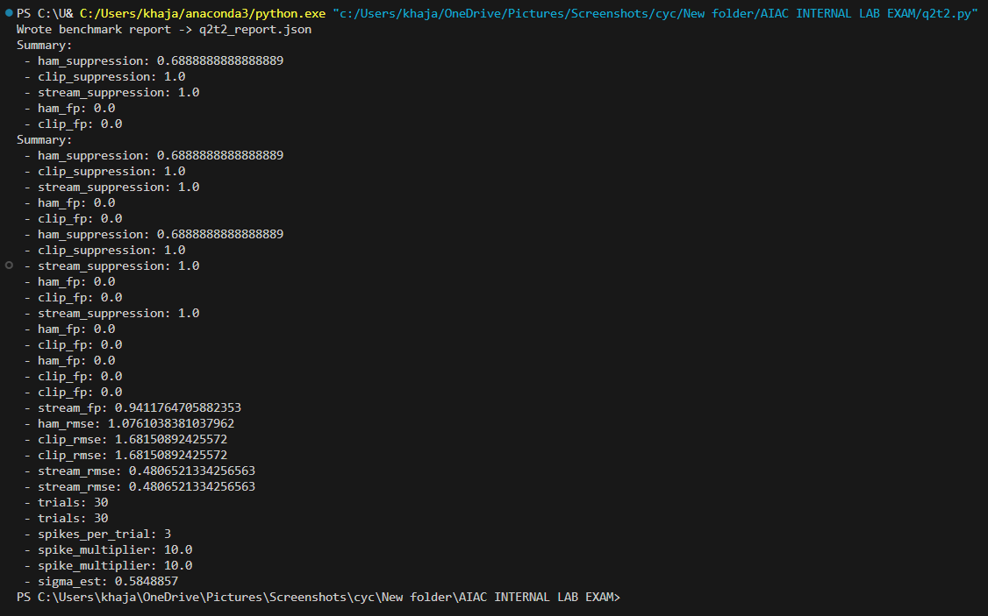

OBSERVATION:-
The AI applied the method and the benchmark showed smoother readings with reduced noise spikes compared to the original data.

